Author: Jessica Stephenson

Skotnes, Cecil
Cecil Edwin Frans Skotnes (b. 1926, East London, Eastern Cape, South Africa. D. 2009, Cape Town, South Africa)

Cecil Skotnes, a print-maker, woodcarver and educator, played a lead role in the mid to late twentieth century South African art world. Together with other young artists of the 1960s, Skotnes forged an art style with a distinctive regional identity as well as ties to international modernism, and he was a founding member of the non-racial Amandlozi Group; yet, it is his role as art teacher and advocate at the Polly Street Art Centre in Johannesburg from 1952 until 1966 that is of paramount significance. Through his efforts a generation of black urban artists were trained and were afforded a network and patronage needed to pursue professional careers. At the time the Polly Street art centre was one of the only institutions that offered black South Africans access to education in modern art media such as painting, graphics and sculpture. Skotnes’ successful promotion of young artists in the 1950s and 1960s made Polly Street a model for other community centers that arose in the 1970s and 1980s, and many of its graduates went on to found or direct community projects such as Community Arts Project in Cape Town, and Funda in Johannesburg. Skotnes was effective in establishing a support network amongst black students and white artists, commercial enterprises, the church and commercial galleries, which aided in launching the careers of a number of students, most notably Sydney Kumalo, Louis Maqhubela, Durant Sihlali and Ephraim Ngatane. He also assisted many young artists through informal mentoring including Lucy Sibiya, David Brown and Willie Bester.

Cecil Skotnes’ personal art style and as well as his approach to pedagogy were shaped by his art education in Europe and South Africa. After completing military service in Europe during WWII, Skotnes studied drawing in Florence under Heinrich Steiner. Returning to South Africa, he completed a fine art degree at the University of the Witwatersrand in 1950 under Heather Martienssen, Douglas Portway and Charles Argent. During this time Skotnes was exposed to traditional West and Central African sculpture. On a return trip to Europe in 1951, Skotnes experienced first hand the work of Pablo Picasso, Henry Moore and other modernists working in a primitivist mode and found them of particular interest. Skotnes came to favor the woodcut print early on, in part through his friendship with African art dealer Egon Guenther who ran a printing press. Sktones experimented with the woodcut medium initially through his use of a large scale format and then, in the early 1960s, he began to explore the possibilities presented by the wood blocks themselves as art works. He engraved, colored and textured them, as seen in Two Figures. Skotnes arrived at a form of primitivism that was in part based in his use of wood and carving, referencing both African sculpture and the print technique of German Expressionism, as well as in his content, which focused on the stylized human form modeled after African sculpture.

Skotnes acquainted his Polly Street art students with traditional West and Central African art as well as certain forms of European primitivism. However, with the exception of Syndey Kumalo, few Polly Street artists drew from the sources favoured by Skotnes because it was believed that to do so would advocate apartheid policies; elements of tradition and “tribalism” were rejected by most Polly Street students because they were considered part of the government’s apartheid strategy of divide and rule. Instead, most Polly Street graduates used the technical training received from Skotnes in watercolor, printmaking and oil painting to work in a social realist manner to portray scenes of township life. There were also practical, financial reasons why Polly Street artists favoured working in these media. Creating works on paper in charcoals and watercolors is both inexpensive and easy to transport.

After the Polly Street art centre closed, Skotnes taught at the Nyanga Art Center and Community Art Project in the Cape during the 1970s and 1980s. Having established planar wood carving as his focus in the 1960s, Skotnes led an active art career through public commissions and an impressive exhibition schedule, both locally at venues such as Goodman Gallery, and abroad. He received numerous awards, several honorary degrees, and his work is extensively represented in collections including Anglo American Corporation New York, USA; Caterpillar Tractor, USA; Johannesburg Art Gallery; Johannesburg Municipal Library; Kettering Gallery, UK; Rembrandt Art Foundation, Stellenbosch; Royal Belgian Library, Brussels, Belgium; Royal Museum of Fine Arts, Copenhagen, Denmark; Sasol; Schlesinger Organisation, London, UK; South African National Gallery, Cape Town; Stuyvesant Foundation, Amsterdam, Holland; and Van Leer Collection, Amsterdam, Holland among others.

References and Further Reading:
Frieda Harmsen (ed.) (1996). Cecil Skotnes, Pretoria: South African Breweries
Elza Miles. (2004). Polly Street: The Story of an Art Centre, Johannesburg: Ampersand Foundation.

Image Caption:
Two figures. Carved, incised and painted wood panel

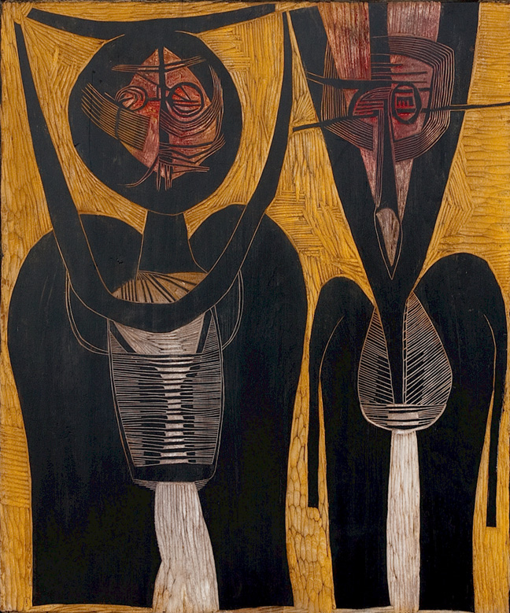
http://www.johansborman.co.za/sa-masters/skotnes-cecil/two_figures_61_x_51_cm.jpg/

